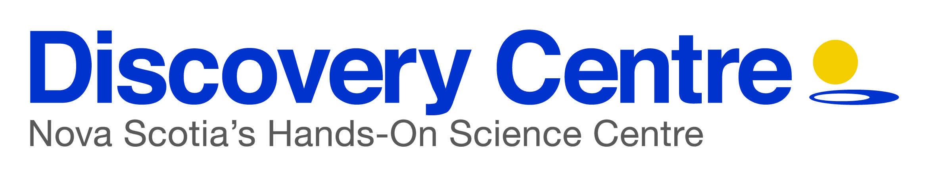

## Tide to Technology:

## *Come Sea the Connection*

You will spend over 62,400 hours working in your professional career. Make every hour count by choosing a career path where you can explore the unknown. *Tide to Technology* is a free external science education program for high school students. Our goal is to have hands on learning in ocean technology. Our one hour workshop consists of stations that provide students with a range of possibilities in ocean technology. ¾ of the world waits for you

## Overview of *Tide to Technology* workshop

Tide to Technology is a station based program that has students circulate each station throughout the one hour program. Here is an overview of the stations:

**Marine Mapping Station:**

Geomatics.  Examples of an echo sounder, multibeam, side scan sonar, LiDar, and seismic reflection tools and how they work.   Maps of Nova Scotia’s coast line and some known information about (ie. Average temperatures, depth including features like the continental shelf, coastal errosian, currents etc.)

* Who is mapping the ocean? And for what purpose?
* What are the best methods of collecting information for specific purposes?
* What are the problems facing ocean mapping?  How has technology changed to tackle some of these issues?
* How could this information collected apply to or influence another sector of science?

**Echolocation Station:**

Marine species can use echolocation for navigation as well as to hunt/ forage.  Students will listen to and observe the frequency of local whale species echolocation sounds. They will then record their own sounds and understand how our sounds differ and why looking at the sounds aids in the study of these species.

* What animals echolocate?
* How are we able to hear the sounds emitted by toothed whales while echo-locating?
* What impact are humans having on jamming the echolocation process?  How are we able to solve this?
* What information can we learn by studying echolocation? How could this information collected apply to or influence another sector of science?

**ROV Station:**

Remote Operate underwater Vehicles are intensively used in underwater exploration and ocean study.  Taking various shapes and sizes these vehicles are most commonly controlled by large fiber optic cables fixed to the ROV and spanning to the land or boat above.  Depending on the role of the ROV, they may be equipped with various tools: lights, magnets, arms, hooks, clamps, suction cups, pressurized sample collecting container but almost all are equipped with cameras.  ROVs are the underwater eyes exploring places humans have never been before. Remote Operated Vehicles play an increasingly important role in ocean exploration.  Why?

Using the “ROV” provided complete the following challenges:

* Drive backwards, forwards and spin around.
* Using the magnetized tool pick up 5 hidden washers
* Park the ROV in the box without scrapping the sides of the bot.

**Ocean Technology Trivia:**

To get a better understanding of the many diverse ocean related careers students compete in this game style trivia to learn about what roles professional in these fields take on.

**We need Your help:**

We are planning an additional station highlighting Nova Scotians in oceans technology careers. Below is a questionnaire about your line of work. If you could include an image of either yourself working/the technology you work with/ or another relevant image; it would help to make the profiles write-ups more engaging.

We would love get some guest speakers/ocean tech professional to deliver on the road with us. Having a guest speaker would be an additional station and be incorporated into the one hour programing. Any professionals interested in more information or sharing their time with Tide to Technology at a local school can contact Kara MacPhee at [kmacphee@discoverycentre.ns.ca](mailto:kmacphee@discoverycentre.ns.ca); 902.492.4422ext227

## Questionnaire

Professional Profilers will be asked to complete the following questionnaire to form the basis of their profile bio. Please complete the questionnaire by **September 26th, 2014.**

**Q. What is your job title and what do you do?**

**Q. Who do you work for and where are you based?**

**Q. What is the salary range for your job?**

**Q. Why is your job important?**

**Q. What kind of equipment/machinery/technology do you use?**

**Q. What do you wish more people knew about oceans?**

**Q. What do you like best about your job?**

**Q. What is the most memorable experience you have had working in your field?**

**Q. What education or training is needed to do your job?**

**Q. What is your advice to someone interested in taking on a similar career?**

Tide to Technology is sponsored by,

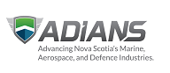

Inline image 2